Convert harddisk met GPT naar MBR. 04122K17

open command prompt met administrator rechten.

1) c:\Windows\system32: diskpart

DISKPART> list disk

Disk ### Status Size Free Dyn GPT
-------- ------------ ----- ------ ---- ---
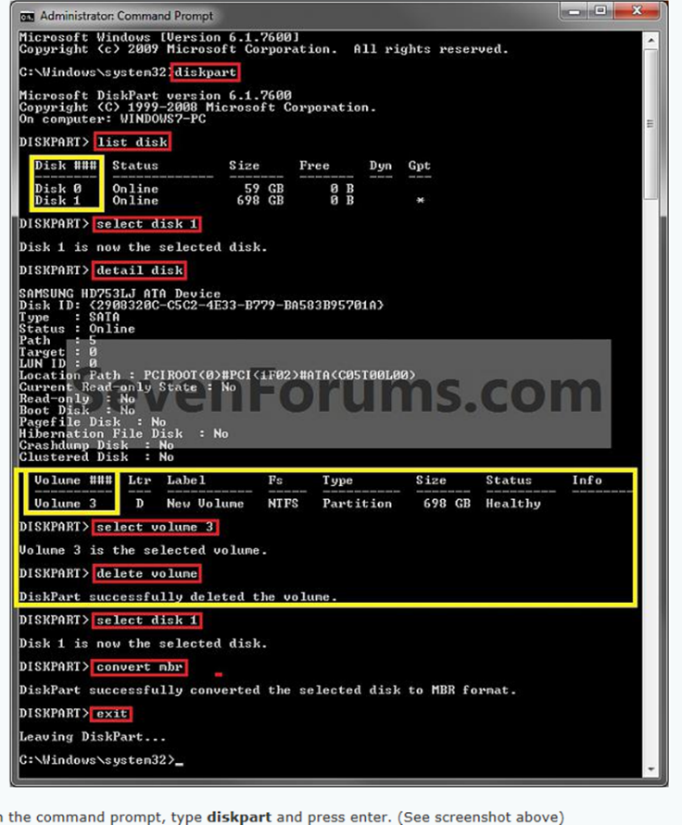
Disk 0 Online 59Gb 0 B
Disk 1 Online 698 0 B *

DISKPART> select disk 1

Disk 1 is now selected disk.

DISKPART> detail disk

Samsung SSD 850 EVO 250Gb
Disk ID: 60AD873D
Type: SATA
Status: Online
Path: 5
Target: 0
LUN ID: 0
Location Path: PCIBOOT <0> #PCI<1F)@>#SATA(C05T00L00)
Current: Read-only State: No
Read-only: No
Boot: No
Pagefile Disk: No
Hibernation: Fiel Disk: No
Crashdump: No
Clusterd Disk: No

Volume ### Ltr Label Fs Type Size Status Info
-------- --- ------------ ----- --------- ------ ------- ---
Volume 3 D New Volume NTFS Partion 250 Gb Healthy

DISKPART> select volume 3

Volume 3 is the selected volume.

DISKPART> delete volume

DiskPart successfully deleted the volume

DISKPART> select disk 1

Disk 1 is now the selected disk.

DISKPART> convert MBR

DiskPart successfully converted the selected disk to MBR farmat.

DISKPART> exit
leaving DiskPart....

Bij Protect melding >> DISKPART> Remove volume…. Error.
Select de drive
DISKPART> clean

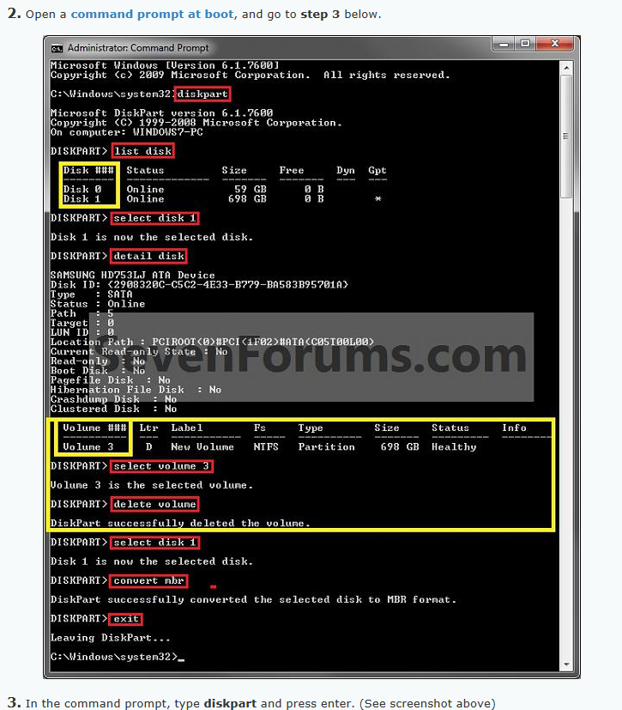

eaving DiskPart....

